Suggested newsletter text: Summer Reading Challenge 2026 in Nottinghamshire inspire Libraries
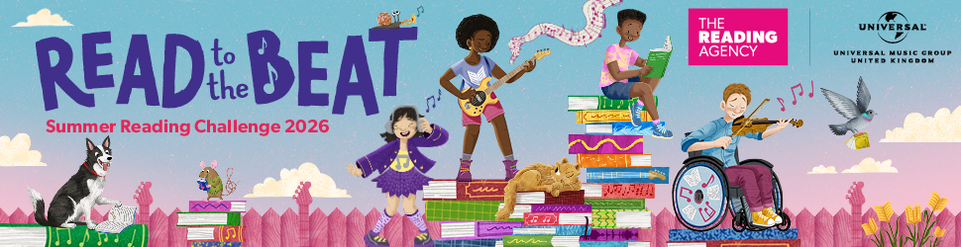

Summer Reading Challenge 2026: Read to the Beat at Nottinghamshire Inspire Libraries 4 July - 6 September
Join the FREE Summer Reading Challenge and earn rewards for reading. This year’s theme is Read to the Beat, celebrating music & sound – exploring how music and storytelling unite.

Summer Reading Challenge 2026: Read to the Beat at Nottinghamshire Inspire libraries 4 July – 6 September
This summer Inspire libraries will be asking children age 4 - 11 to find their reading rhythm in the 2026 Summer Reading Challenge: Read to the Beat.

Children select and complete six reading goals of their choice over the summer, collecting rewards along the way. Every child who completes the challenge will receive a certificate and medal.

Produced by The Reading Agency and delivered in partnership with libraries across the country the Summer Reading Challenge is a great opportunity for children to find books they love.

They choose what they want to read – story books, information books, e-books, audio books, poetry, comic, joke books, and graphic novels, all reading counts –children set the tempo!

Read to the Beat is running in all Inspire libraries until Sunday 6 September, suitable for children aged 4 – 11. It’s completely FREE to take part.

Under 4s can take part in our mini challenge too.

Find out more at www.inspireculture.org.uk/summerreadingchallenge

